|  |
| --- |
| **PT. BERLIAN SISTEM INFORMASI** |
| Operating Lease – SKD Process |
| **USER MANUAL** |
|  |
| **VERSION 2.1** |
| **6/29/2016** |

|  |
| --- |
| All material contained in this manual including text, graphics, icons and images contain proprietary and confidential information of PT. Berlian Sistem Informasi and are protected by international intellectual property and other laws. The compilation of all text, graphics, icons and images in this Manual is the exclusive property of PT. Berlian Sistem Informasi. No modification, rental, lease, sale, transmission, distribution, reposting or creation or derivate works based on the material in this Manual is allowed, unless with the express permission of PT. Berlian Sistem Informasi. |

# REVISION HISTORY

|  |  |  |  |
| --- | --- | --- | --- |
| **Date** | **Revision** | **Description** | **Author** |
| 1/6/2016 | 0.0 | Initial Document | Sabilla Pravita Larassati |
| 3/3/2016 | 0.1 | Update Information and Screenshot | Sabilla Pravita Larassati |
| 3/16/2016 | 0.2 | Compiled with SKD Approval and Complement Document process | AR. Anggun Cahyaningtyas |
| 1.0 | 1st Baseline | AR. Anggun Cahyaningtyas |
| 5/3/2016 | 1.1 | Update Document | Sabilla Pravita Larassati |
| 5/4/2016 | 2.0 | 2nd Baseline | Grand Zah Putra |
| 6/29/2016 | 2.1 | Revision 2nd Baseline and transfer Monitoring Complement Document to User Manual Agreement | Alifa Karomina Putri |

# TABLE OF CONTENT

REVISION HISTORY 2

TABLE OF CONTENT 3

MARKETING MODULE 4

1. MANAGE SURAT KEPUTUSAN DIREKTUR (SKD) 4

1.1. Show List of SKD Record Data 4

1.2. Filter and Sort SKD List 6

1.3. Create New SKD 7

1.4. Edit an SKD Draft 10

1.5. View an SKD 13

1.6. Print SKD Form 16

1.7. Print SKD Report 18

2. SKD APPROVAL 19

Prerequisites 20

2.1. Check and Revise SKD 20

2.2. Approve or Reject SKD 23

# MARKETING MODULE

Operating Lease Support System includes Marketing Module features; Calculation Cashflow, Quotation of Refinance, **Visit Customer Survey, Board of Director Decree / SKD Process, and Agreement Information Inquiry**. All features will be described in the subsequent sections. The Marketing menu of Operating Lease Support System serves as the basic access to marketing module and records of all data. With the marketing menu, you will be able to utilize features of marketing module, including information that will be adjusted through other features of Operating Lease Support System.

Additionally you can enter a record, make changes, and inspect a detail record, and also filter specific records based on columns by writing a keyword on the search field. The features and data contained in your Operating Lease Support System menu are limited by your security and data authorization settings so you may not be able to access all features.

# MANAGE SURAT KEPUTUSAN DIREKTUR (SKD)

Surat Keputusan Direktur (SKD) process is triggered after customer agrees about the quotation, and PO already submitted to DSF. Marketing Officer (MO) can create SKD based on quotation reference that already submitted to customer. One SKD refers to one quotation document. Manage SKD module provides several functions:

1. Create new SKD, within save as draft and/or submit.
2. View details of SKD information.
3. Filter and sort function.
4. Modify SKD information; keep them up-to-date.
5. Print SKD report and SKD form.

## Show List of SKD Record Data

To check the list of SKD, here is the procedure:

1. Navigate to Marketing module and click “Board of Director Decree / SKD Process”.

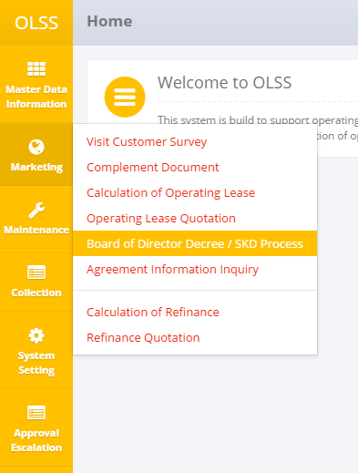

Screen 1: Marketing Menu – SKD Process Menu

1. System shows List of SKD screen that consist of SKD that already recorded in the system. The main page of List of SKD is shown below:

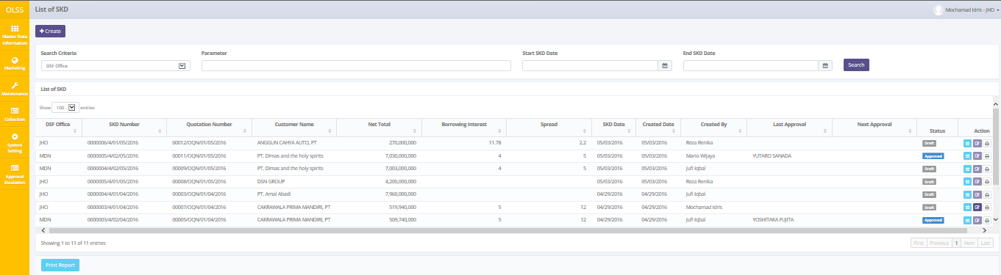

Screen 2: List of SKD

SKD Document statuses are divided into 7 types:

1. , the document hasn’t been submitted by MO, still can be edited.
2. , the document can no longer be edited, and ready to be checked by DSF management.
3. , the document has been checked by DSF management, and continues to the next approval hierarchy.
4. , the document has some mistakes and the Checker has revised it. Document need to be submitted back by Marketing Officer.
5. , the document has been approved by the highest hierarchy.
6. , the document has been rejected by the highest hierarchy.
7. , the document has been escalated by previous checker.

On the List of SKD screen, there will be five buttons, which are:

* 1. : On top-left screen, click the button to create new SKD.
  2. : In the action column in each record, click the button to view SKD details.
  3. : In the action column in each record, click the button to modify SKD information.
  4. : In the action column in each record, click the button to print SKD form.
  5. : On bottom-left screen, click the button to print SKD list report.

## Filter and Sort SKD List

To filter the records there are three categories as follows:

1. To sort the record alphabetically by column, user can click  on the column title on the table header.
2. User can select the number of records that want to be showed by picking this feature  on the screen. If the records have been filtered based on number, the amount of records that will be shown is the same as the selected number.
3. User can filter the records with the specific information by entering the keywords on the search field shown below:

Search criteria consist of:

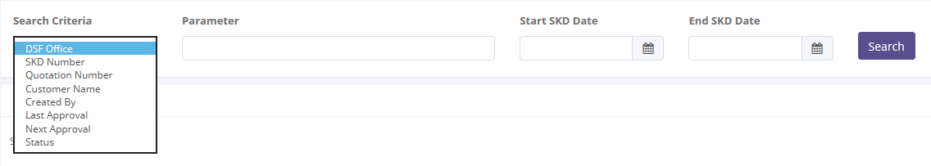

Screen : Search Field

Parameter can be filled with keywords that user want to search. To get more specific results, user can also insert the SKD date (Start SKD Date and End SKD Date). For example, you can find name by filling the keywords in parameter, and pick **Customer Name** in Search Criteria, then pick the exact date, and press Search button to get the results.

## Create New SKD

To create new SKD, find and click Create on top of the List of SKD Screen.

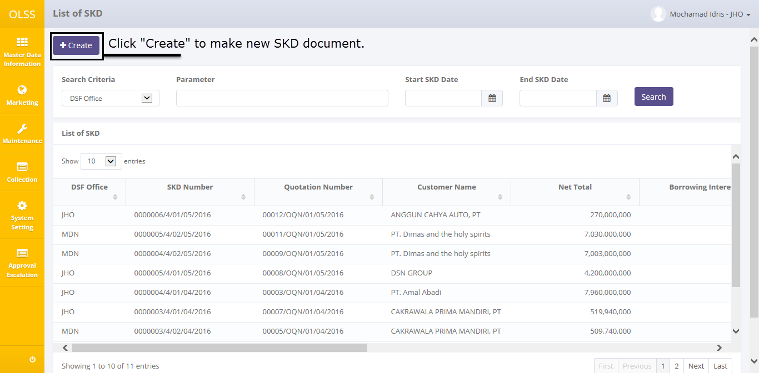

Screen 4: Create button on List of SKD

System will show Create SKD Screen and list of entries consist of:

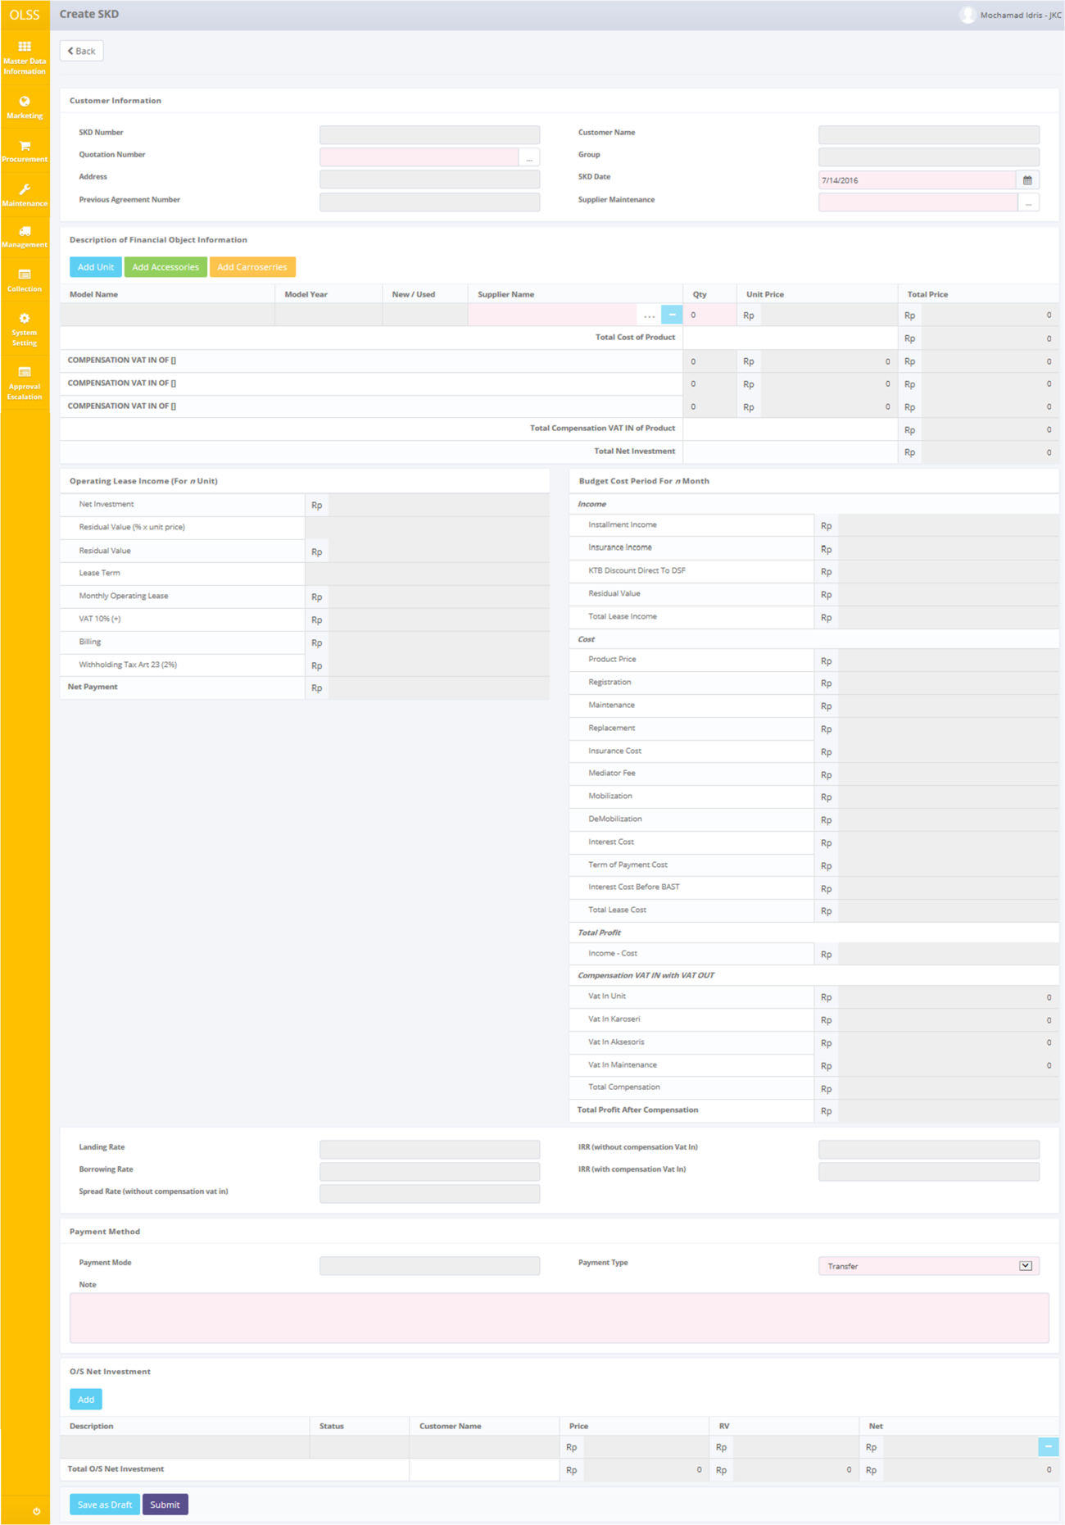

Screen 5: Create SKD

Once the Create SKD screens open, user has to fill information on the blank field. The fields are:

1. Customer Information
   1. Quotation Number: Select Quotation number on Quotation Data pop-up screen. If selected quotation number is created using Rescheduled or Novation agreement, previous agreement number will show up in Previous Agreement Number field. Selecting quotation number will generate new SKD number and automatically load up quotation information.
   2. SKD Date: Default input current date.
   3. Supplier Maintenance: select vendor for maintenance. Field is disabled if current customer didn’t request for maintenance.
2. Description of Financial Object Information
   1. Model Name, Model Year, New/Used, Unit Price and Total Price information will automatically listed, user just have to select supplier and input quantity. Click  if units are ordered with different suppliers.
   2. , click to add caresorries, input model name, select supplier, input carrosseries price, and quantity. Please input the price as inputted in Calculation. False price will result in Error Message upon saving.
   3. , click to add accessories, input mode name, select supplier, input accessories price, and quantity. Please input the price as inputted in Calculation. False price will result in Error Message upon saving.
   4. , click to remove row.
3. Payment Method:
   1. Payment Type: Pick “Transfer” or “Giro/PDC”
   2. Note: fill with necessary information regarding payment method.
4. O/S Net Investment: Any SKD documents relate with the same customer will list here. Click **Add** to give additional data.

There are three buttons that will be displayed on the screen as follows:

1. , on the top-left corner of the screen, to go back to previous screen: List of SKD.
2. , on the bottom-left corner of the screen, to save document as draft.
3. , on the bottom-left corner of the screen, to submit document.

There are mandatory fields marked with red background field that should be inputted including; Quotation Number, SKD Date, Supplier Maintenance, Supplier Name, Quantity, Unit Price, Payment Type, and Note. It can’t leave as blanks. If you leave them blanks, system will notified it as error after you clicking **save as Draft** or **Submit** button.

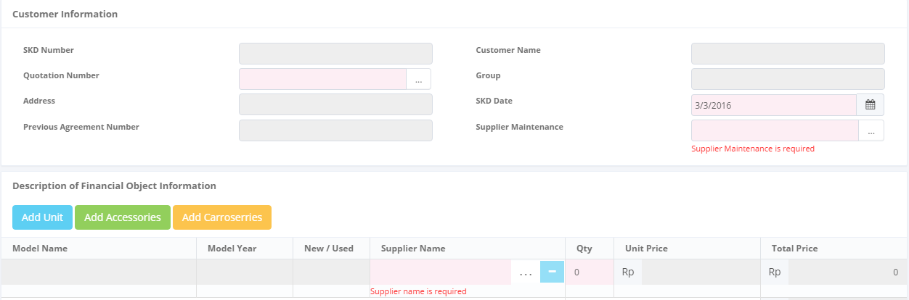

Screen 6: Error Message on Mandatory Fields

After the data entered on the screen, user can save the information on the system by clicking **Save as Draft** button, or **Submit** button. Ensure that you actually want to **submit** a record, because the records can’t be reserved and update after submitted by user. After clicking **Save as Draft** or **Submit** button, a pop up will display confirmation:

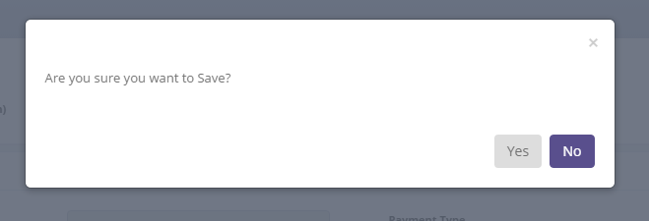

Screen 7: Pop up confirmation dialog

Click Yes button to save/submit the data. Screen will automatically go to List of SKD screen. Then system will notified if it success or failed to save or submit a data.



Screen 8: SKD Success notification upon saving

## Edit an SKD Draft

To edit an SKD record, navigate to List of SKD screen and click Edit button on the right side of the record. Edit button is enabled for records created by the same user, and records with status “draft” and “Revise”.

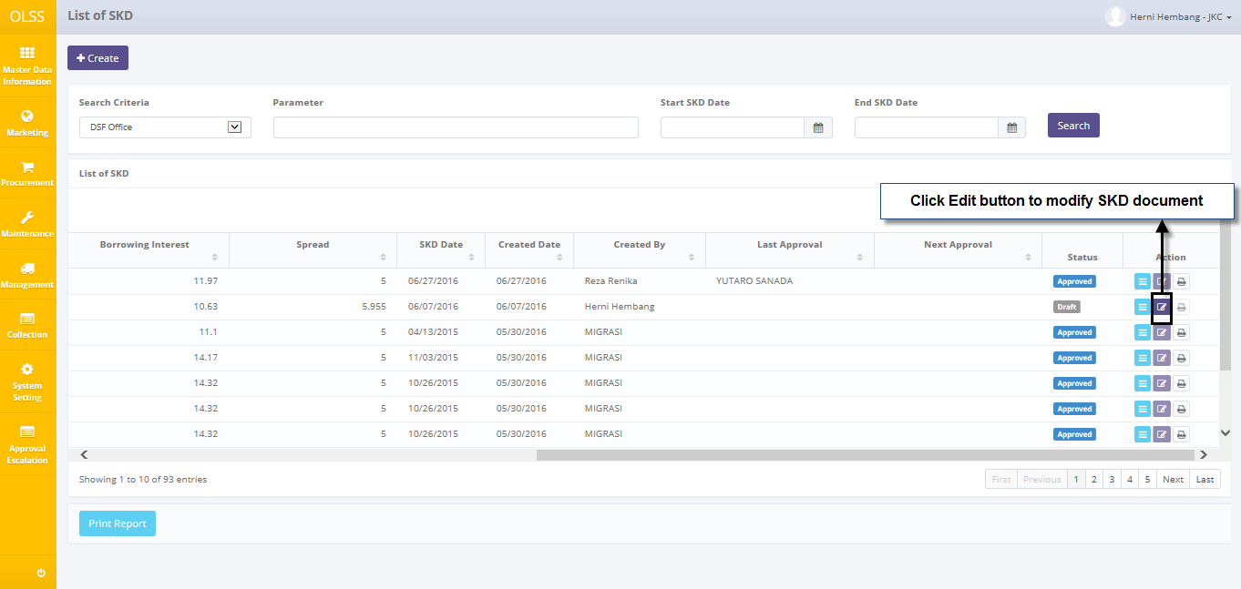

Screen 9: Edit button on List of SKD

The screen below is shown after the Edit button is clicked.

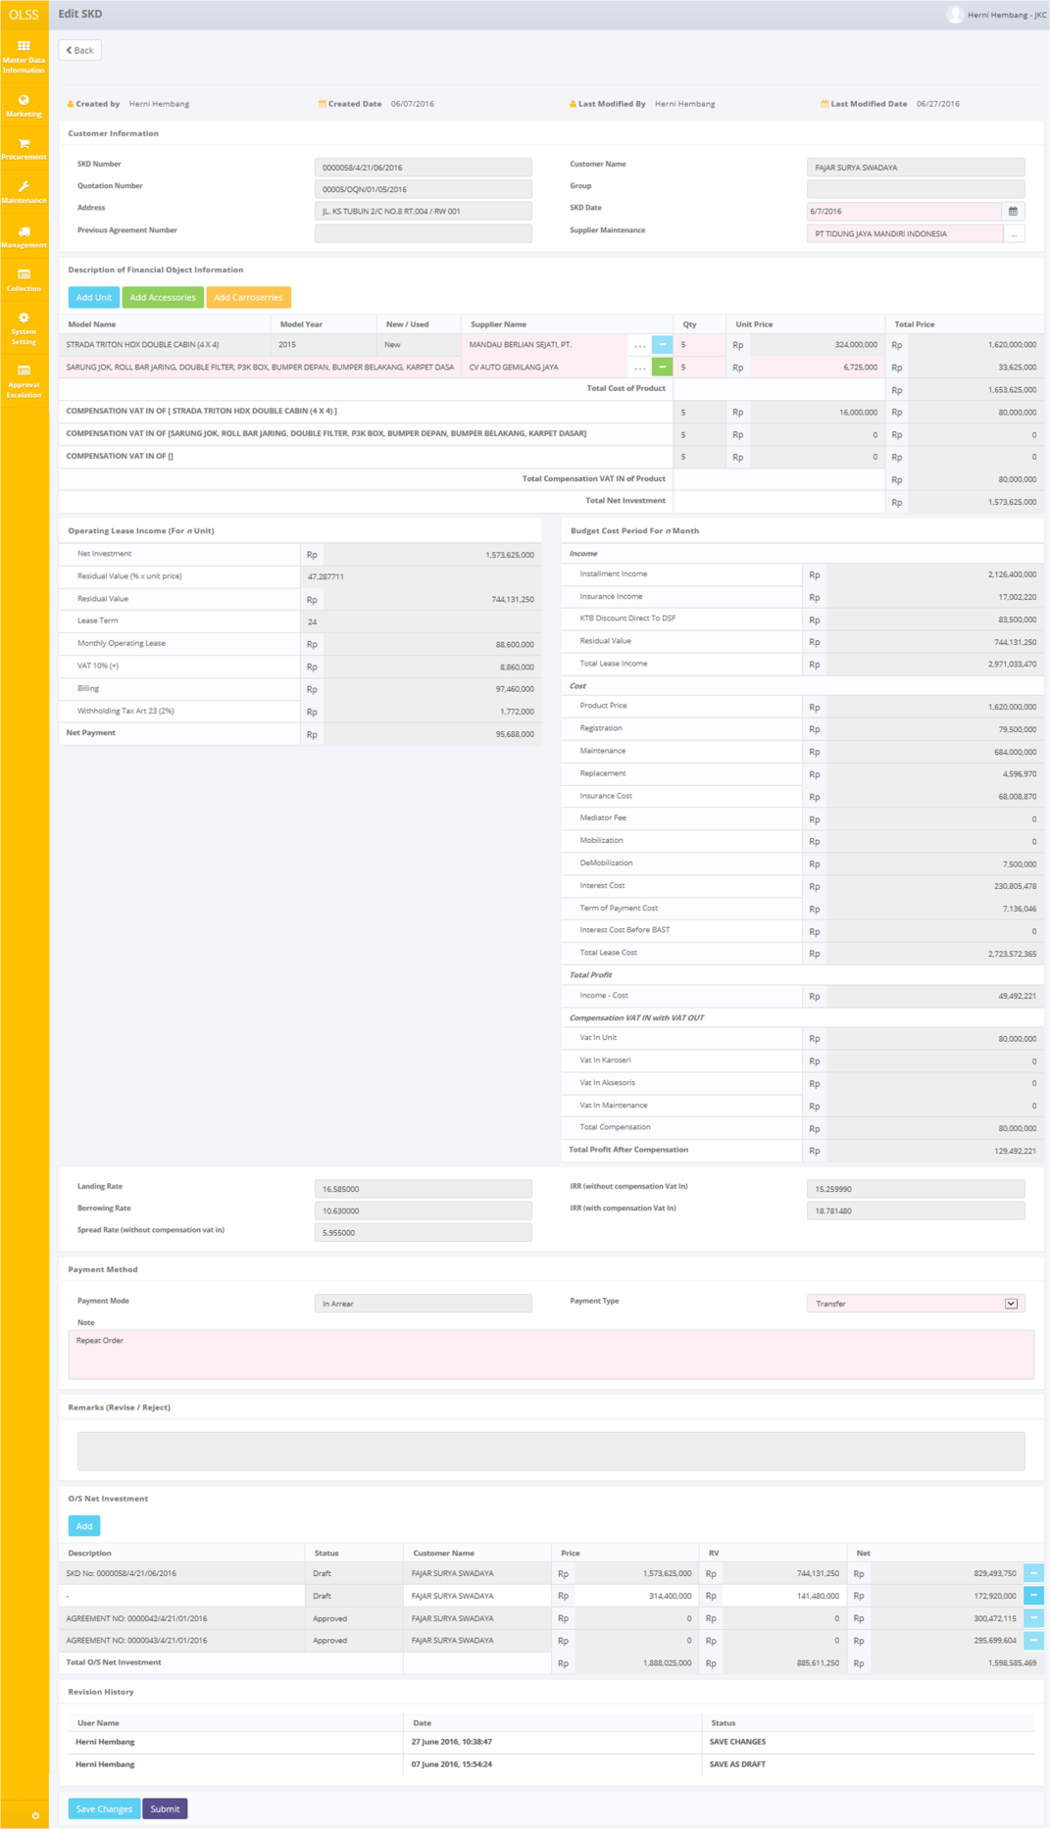

Screen 10: Edit SKD

Once the Edit SKD screens open, user can see Created by, Created Date, Last Modified by and Last Modified date information on top of the screen. Quotation number field can no longer be modified. Other than that, user can edit the information existed. There are three buttons that will be displayed on the screen as follows:

1. , on the top-left corner of the screen, to go back to List of SKD screen.
2. , on the bottom-left corner of the screen, to save changes on current document.
3. , on the bottom-left corner of the screen, to submit document.

There is a Revision History field on the bottom of the screen that consist of the user information who has made changes to the record. If data already entered on the screen, user can save a data on the system by clicking **Save Changes** button, or **Submit** button. Ensure that you actually want to **Submit** a record, because the records can’t be reserved and update after submitted by user. After clicking **Save Changes** or **Submit** button, a pop up will display confirmation:



Screen 11: Pop up confirmation dialog

Click Yes button to save/submit the data. Then system will notified if it success or failed to save or submit a data. Screen will automatically go to List of SKD screen.



Screen 12: SKD notification upon submitting

## View an SKD

To view the records, you can select a record from the customer list page by clicking the action button, on the rightmost column.

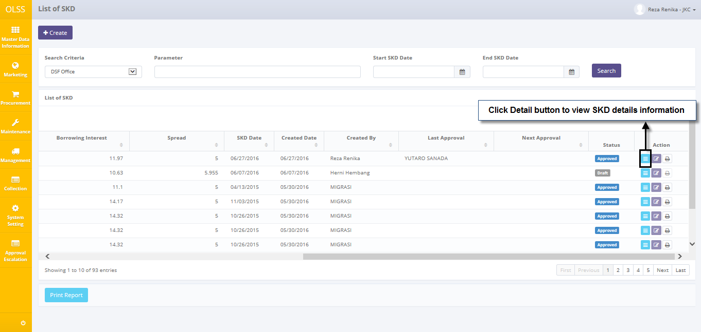

Screen 13: Details button on List of SKD

Below is View SKD screen:

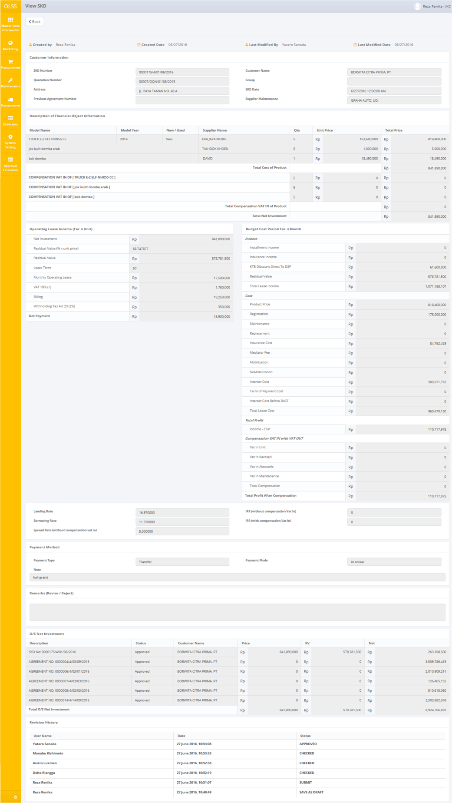

Screen 14: SKD Detail

User can check the records but the records cannot be clicked or edited. Here you can see the detail information related with SKD Data, such as; Customer Information, Description of Financial Object Information, Operating Lease Income (For n unit), Budget Cost Period For n Month, Payment Method, and O/S Net Investment.

For Marketing Officer Role, there is only one button that will be displayed on the screen which is. After done viewing the records, you can click **Back** button, to redirect you to the previous page, List of SKD Page.

## Print SKD Form

User can also print the records by clicking the button Print Form SKD on the List of SKD screen as shown below:

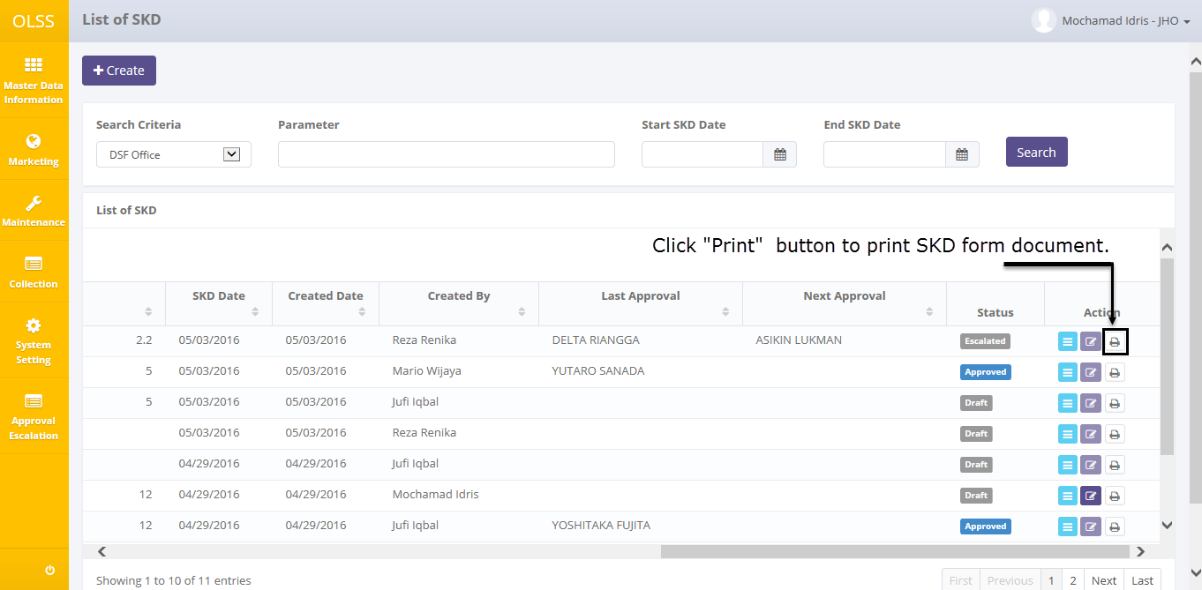

Screen 15: Print button on List of SKD

After clicking the button, system will show print preview of the SKD form. User can choose to print the document or save document as Excel or PDF.

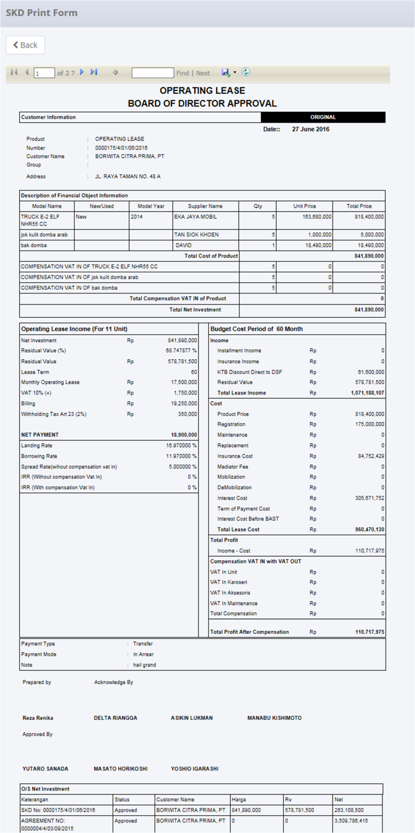

Screen 16: Print preview for SKD form

## Print SKD Report

Aside from printing SKD form, user can print the entire SKD list that has been recorded in or print SKD by specific criteria, for example “SKD document from January to May Report” by using the Search function before printing. To print the report, user can click Print Report button on the bottom of List of SKD Screen.

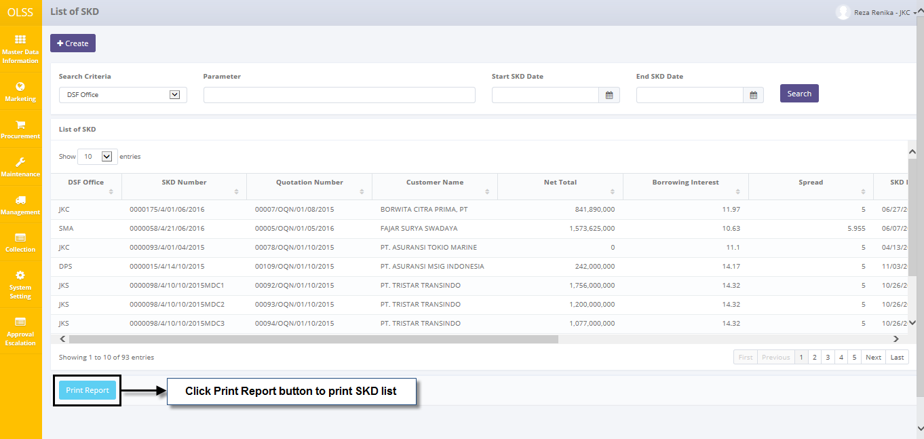

Screen 17: Print Report button on List of SKD

After clicking the button, system will ask user to open or save the document. Document will be saved or opened in Excel.

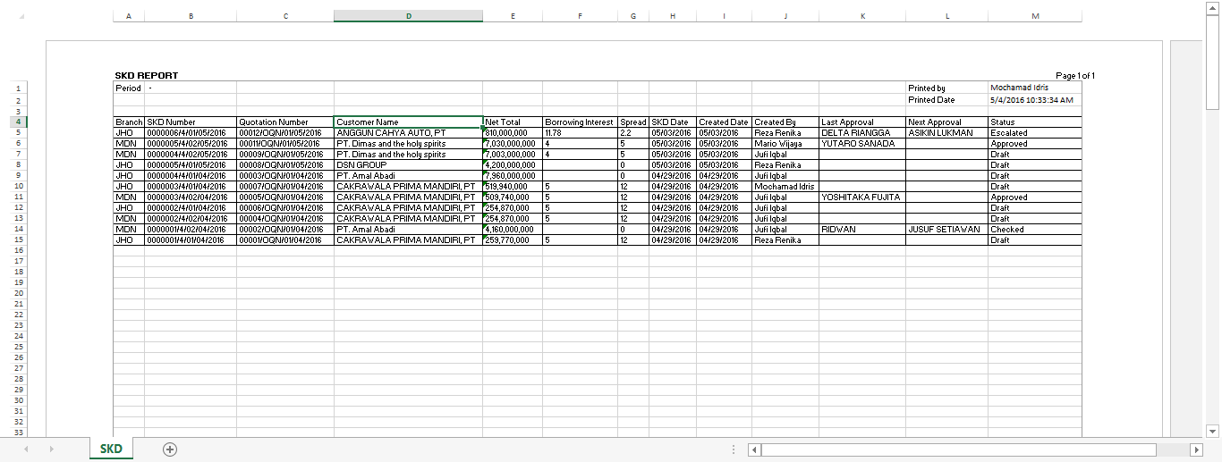

Screen 18: SKD Report

# SKD APPROVAL

Surat Keputusan Direktur (SKD) can be approved once it is submitted by PIC Marketing Officer. SKD will be approved by DSF management which is: Head of Branch/Head of Division, Regional Manager, Advisor, Director, and President Director. Approval hierarchy is based on SKD Net Investment Nominal. The highest the nominal, the higher hierarchy to check and approve SKD. The nominal table can be seen below:

Table 1: Nominal Table

|  |  |  |  |
| --- | --- | --- | --- |
| **Amount Range (IDR)** | **Proposed** | **Checked** | **Approve** |
| 0 – 14.999.999.999 | MO | HOB/HOD, RM, REGIONAL OFFICER, ADVISOR | EXECUTIVE GENERAL MANAGER RESEARCH & DEVELOPMENT/  MKT DIRECTOR/  REGIONAL DIRECTOR/  DIRECTOR FOR COLLECTION, LEGAL & HUMAN RESOURCES/  EXECUTIVE GENERAL MANAGER FINANCE/  OPERATION DIRECTOR/  VICE PRESIDENT DIRECTOR/  PRESIDENT DIRECTOR |
| 15.000.000.000 – 59.999.999.999 | MO | HOB/HOD, RM, REGIONAL OFFICER, ADVISOR, EGMRD | PRESIDENT DIRECTOR |
| ≥ 60.000.000.000 | MO | HOB/HOD, RM, REGIONAL OFFICER, ADVISOR, EGMRD | SHARE HOLDER MEETING |

*Nominal table can be varied based on DSF setting on Approval Path Setting

SKD should be checked by one or more authorized person, before approved by the highest hierarchy user. If one user isn’t available under some circumstances, the document approval can be escalated to the next role level (refer to User Manual: System Setting).

SKD approval module provides two functions, which are:

1. Check and Revise SKD document.
2. Approve and Reject SKD document.

# Prerequisites

Before user can do any actions related with SKD, user has to login using the right authorized username, for example: as HOB, RM, and director.

## Check and Revise SKD

SKD can only be checked by specific user. User who able to check is user stated in Next Approval column. To start checking SKD record, navigate to the List of SKD and click View button on the right side of the record with status .

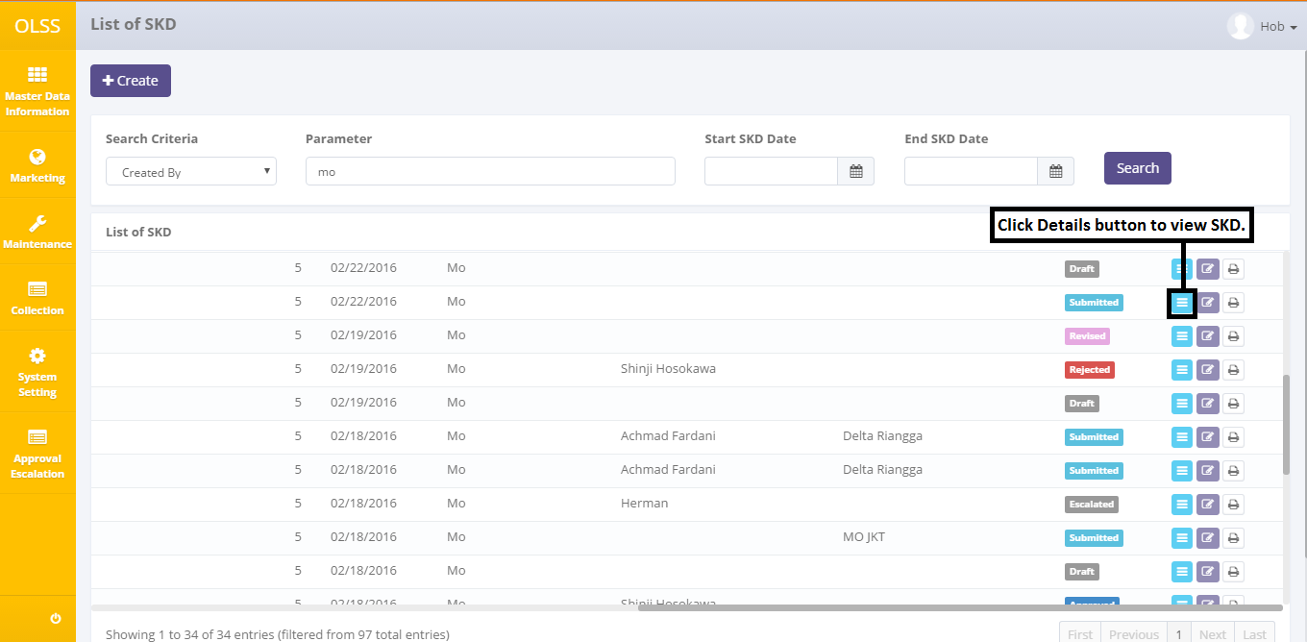

Screen 19: Details button on List of SKD for submitted SKD

The screen below is shown after the View button is clicked.

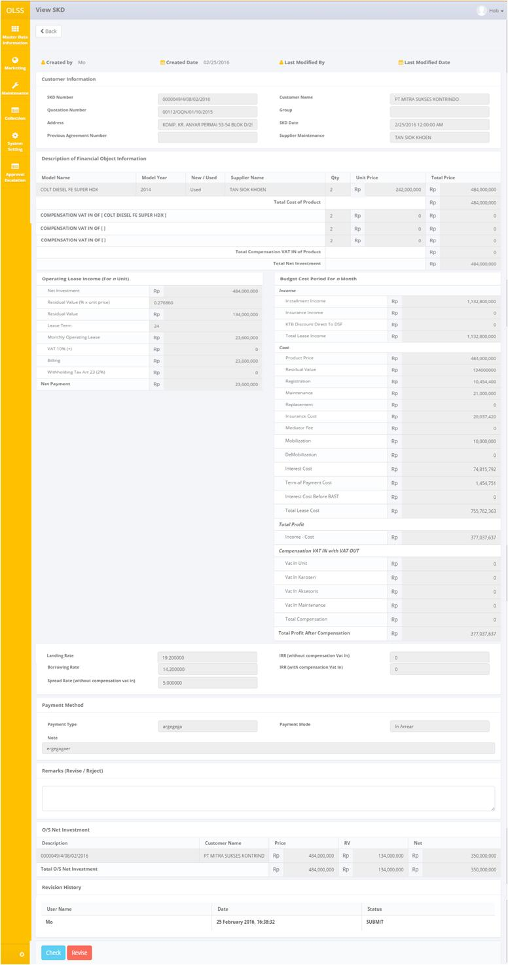

Screen 20: SKD Details for Checker

Once the View SKD screens open, user can check the information existed. There are three buttons that will be displayed on the screen as follows:

1. , to go to previous screen: list of SKD.
2. , to give a sign that current approver has check the document and ready to send the document to the next approver. The button will not active for the highest hierarchy approver (refer to nominal table). After the button is clicked, SKD status will change to .
3. , to give a sign that the document need revision and have to be submitted again by Marketing Officer. After the button is clicked, SKD status will change to .

While checking, if SKD still need to be revised, fill Remarks with revision information and click “Revise” button. The document will sent back to MO to be submitted back.

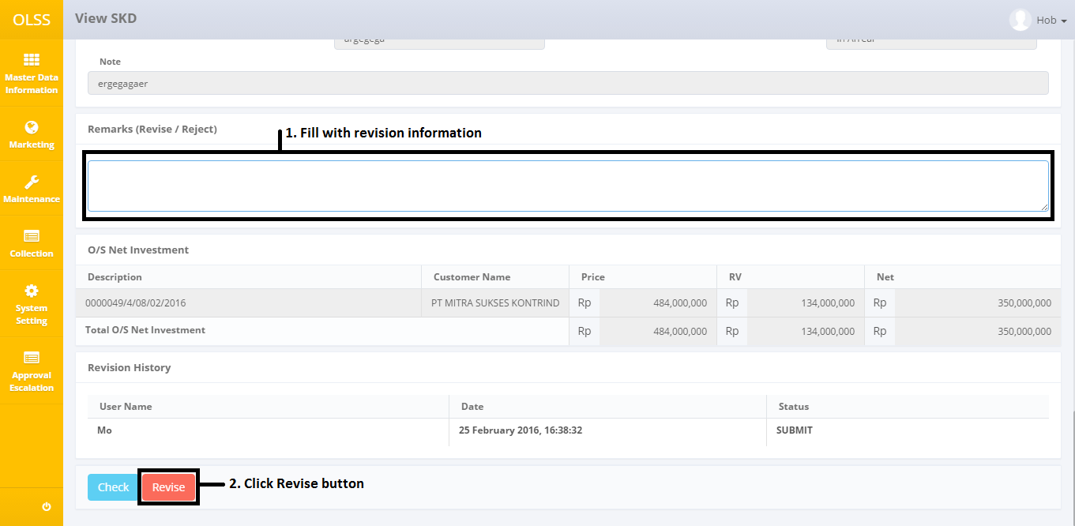

Screen 21: Revision step

If data has no more mistakes, user can click “Check” to continue the document to be checked by next approver. After clicking **Check** or **Revised** button, confirmation pop up dialog will show, click Yes to continue.

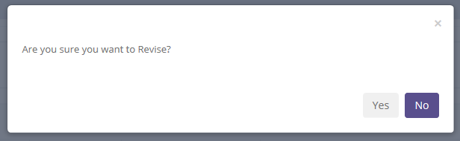

Screen 22: Revise confirmation pop up screen

Then system will notified if it success or failed to save or submit a data.



Screen 23: Success notification after document is checked



Screen 24: Success notification after document is revised

System will automatically change screen to List of SKD. Then the document can no longer be Checked/Revised by current user, because the authority has been passed to the next approver. For this case, if HOB is the current user, HOB can’t edit the document. User who have changed the data will be registered in Revision History field at the bottom of the document.

## Approve or Reject SKD

SKD can only be approved by the highest hierarchy (refer to nominal table). To approve an SKD, click View button on the right side of the record with status  and has the highest hierarchy name as next approver. For example: if the highest hierarchy for the case is Director, then the “Next Approver” name should be Director Name.

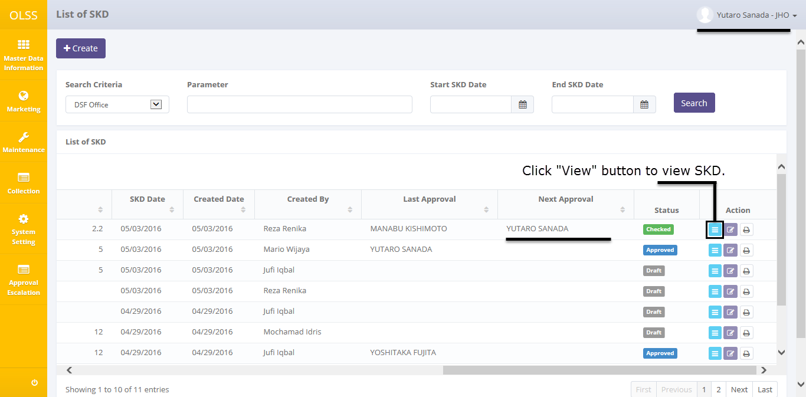

Screen 25: Details button on List of SKD for approver

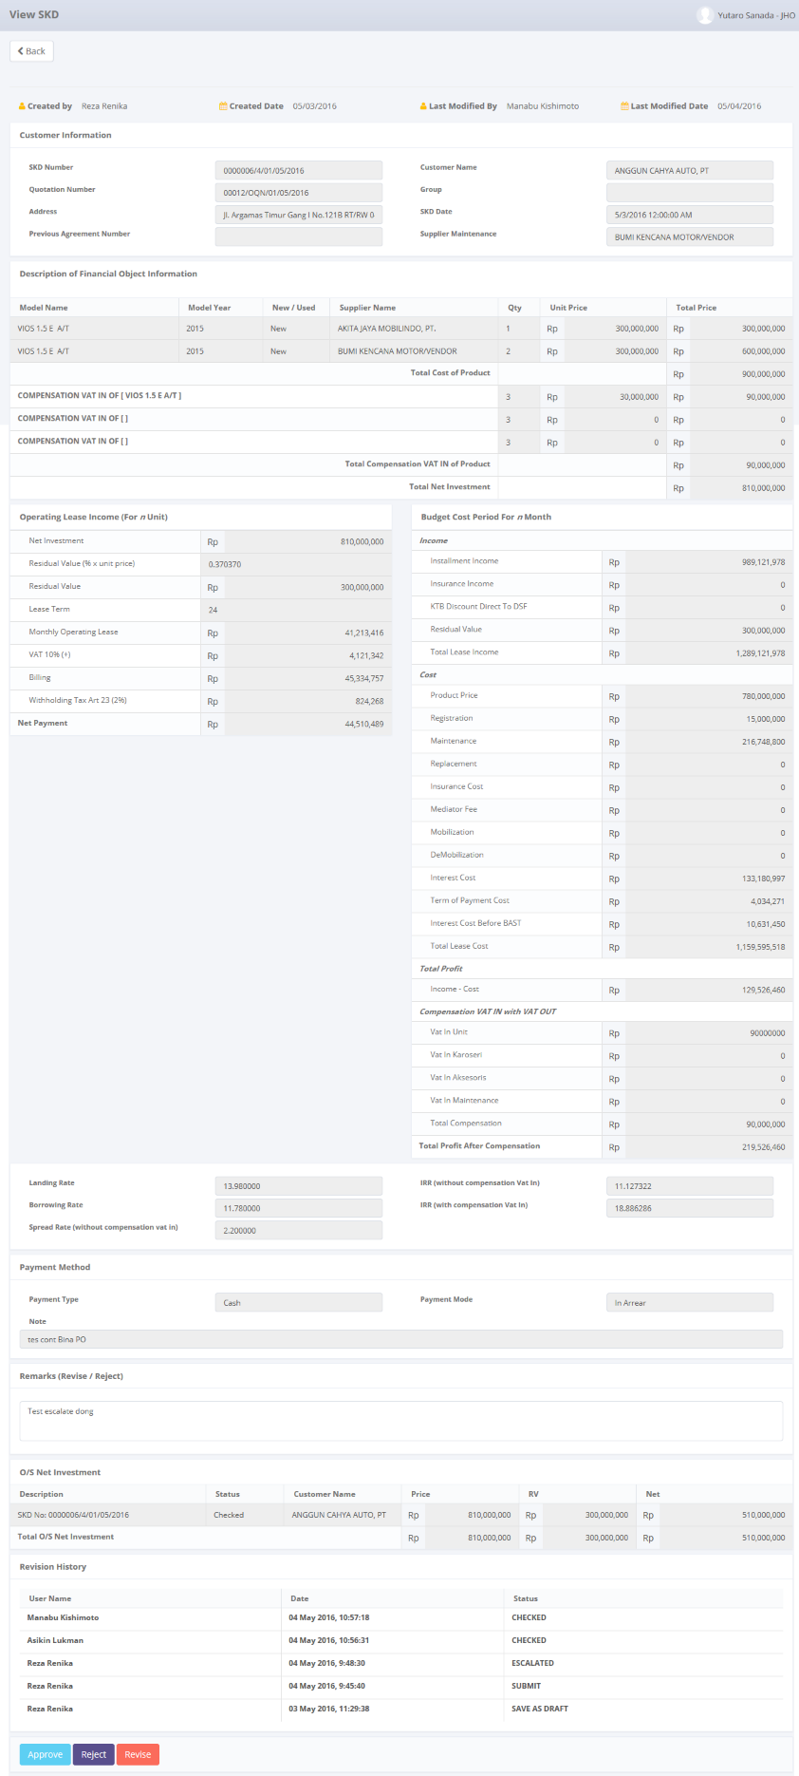

Screen 26: SKD details for highest hierarchy user

View SKD screen will show up, and on the bottom of the screen there are four active buttons:

1. , to go to previous screen: list of SKD.
2. , to give a sign that user has approve the SKD. Only active for highest hierarchy user. SKD status will change to .
3. , to give a sign that document is rejected by the highest hierarchy (refer to nominal table). SKD Status will change to .
4. , to give a sign that the document need revision and have to be submitted again by Marketing Officer. SKD status will change to .

If SKD will be rejected, user has to fill remarks with rejection reason. Then click Reject button on the bottom of the screen.

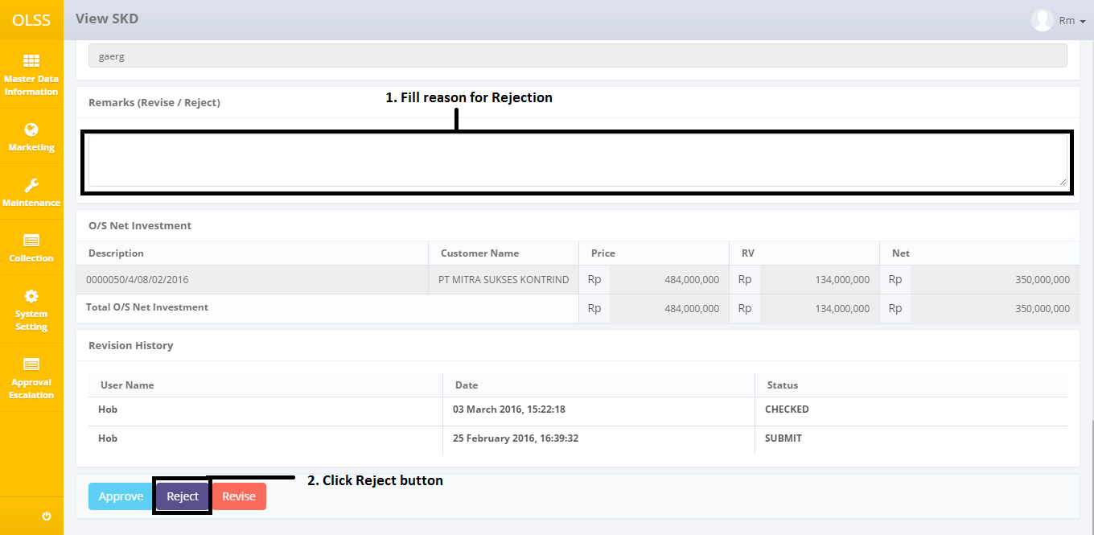

Screen 27: Rejection step

After clicking **Approve, Reject** or **Revised** button, confirmation pop up dialog will show, click Yes to continue.

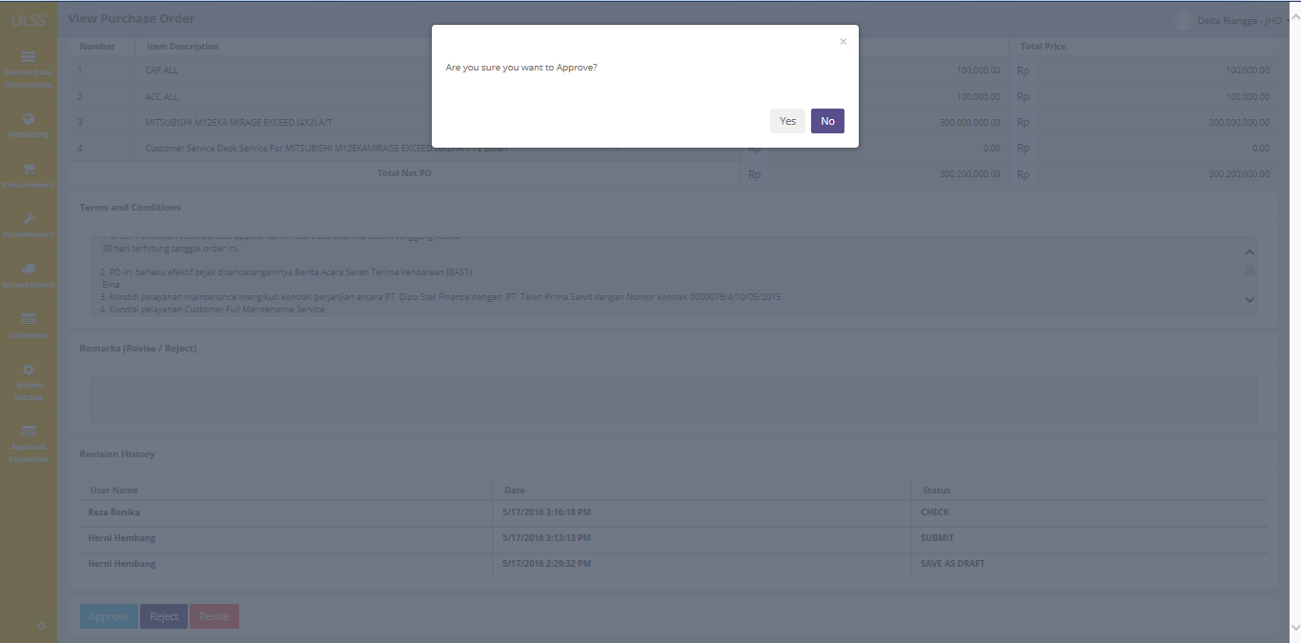

Screen 28: Approve confirmation pop-up

Then system will notified if it success or failed to approve or reject a data.



Screen 29: Success notification after SKD is rejected



Screen 30: Success notification after SKD is approved

Then the document can no longer be modified by current user.